**Sprint 2 Personal Portfolio**

(Group 68)

(Doug Brennan – n7326645)

(https://github.com/NickIsReady/Group-68-Web-System)

**Artefact 1** – (Contacts Page)

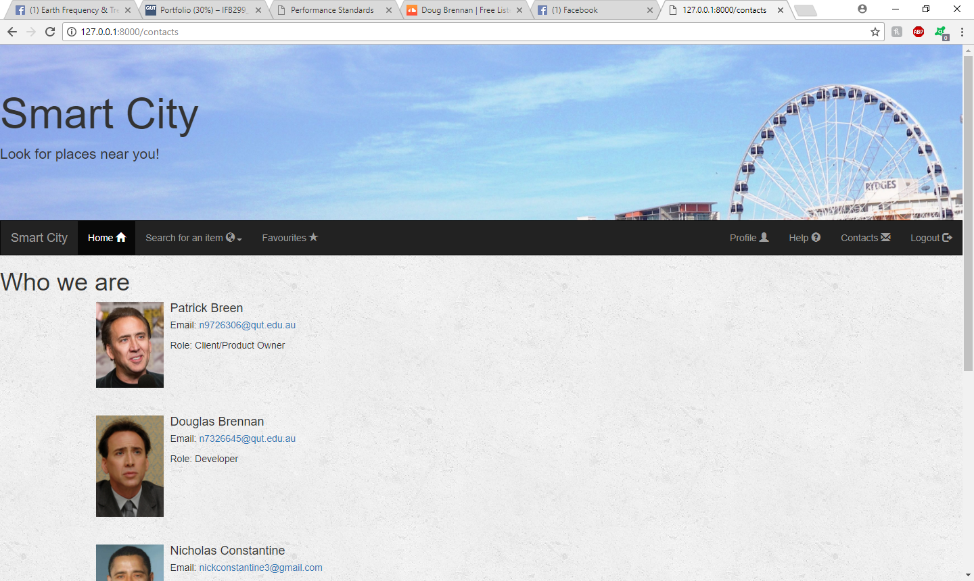

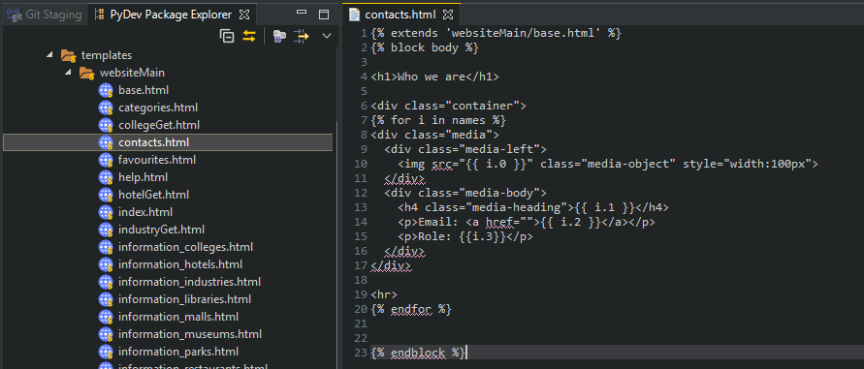

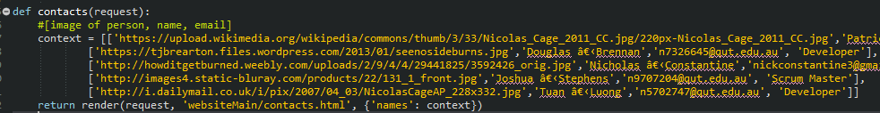

Description: This function is used to diplay the contacts page so that website visitors are able to get in contact with the desired project members.

Github: <https://github.com/NickIsReady/Group-68-Web-System/blob/master/websiteMain/templates/websiteMain/contacts.html>

Relevant story from sprint – 21

**Artefact 2** – (User Profile Page)

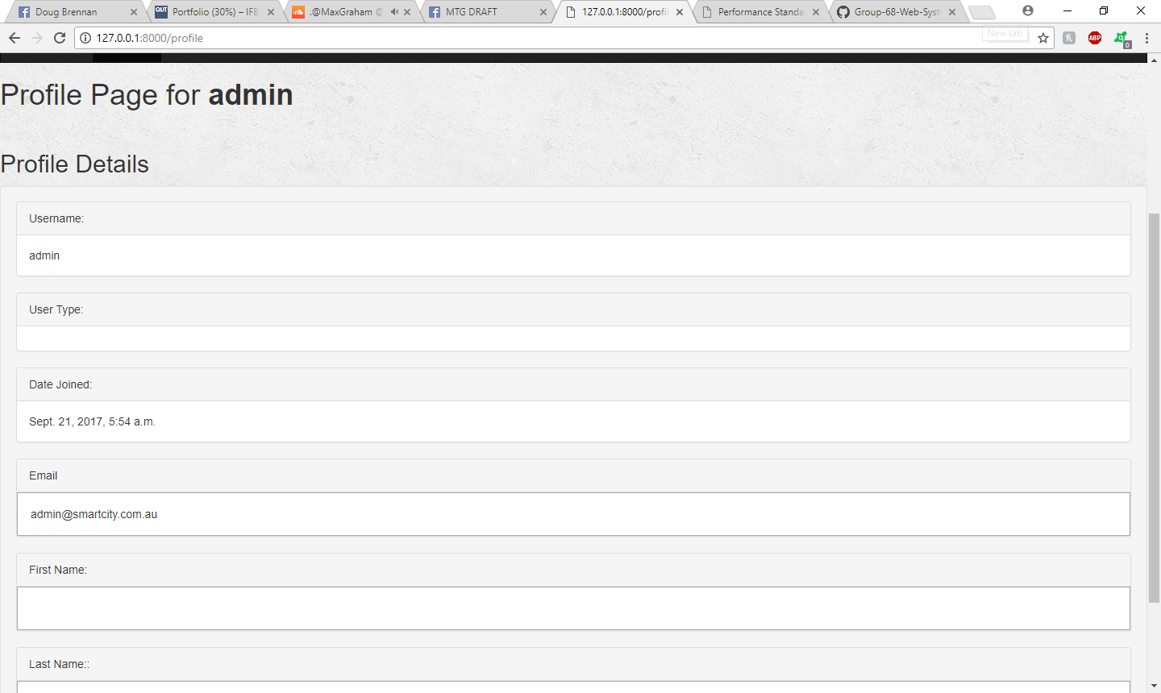

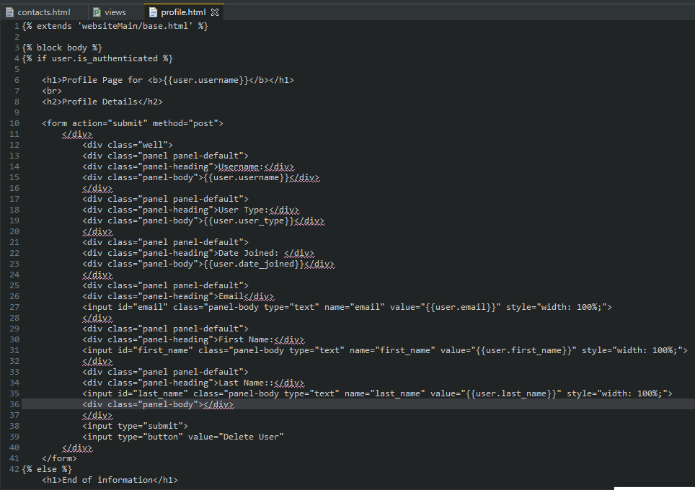

Description: This page is so that users can view and update their profile information, the front end functionality was implemented but sadly I was unable to implement the forms functionality due to difficulty.

Github: <https://github.com/NickIsReady/Group-68-Web-System/blob/master/websiteMain/templates/websiteMain/profile.html>

Relevant story from sprint – 18

**Artefact 3** – (View Specific POI Details)

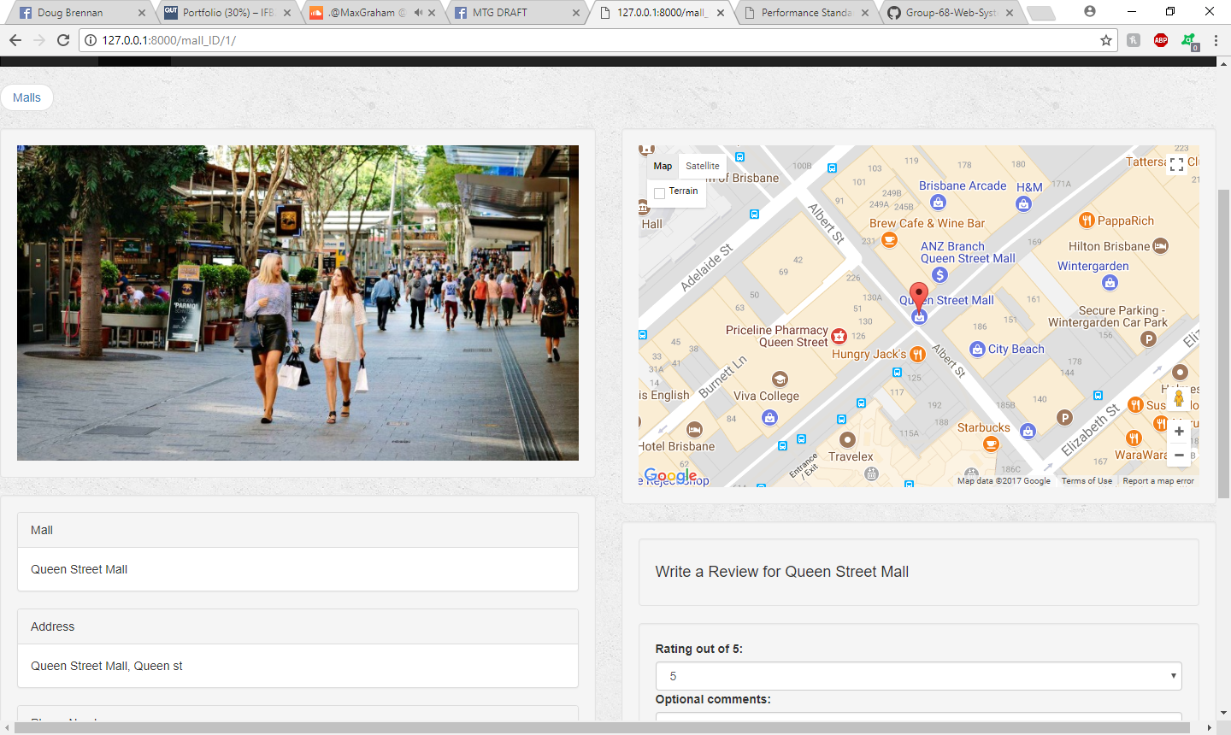

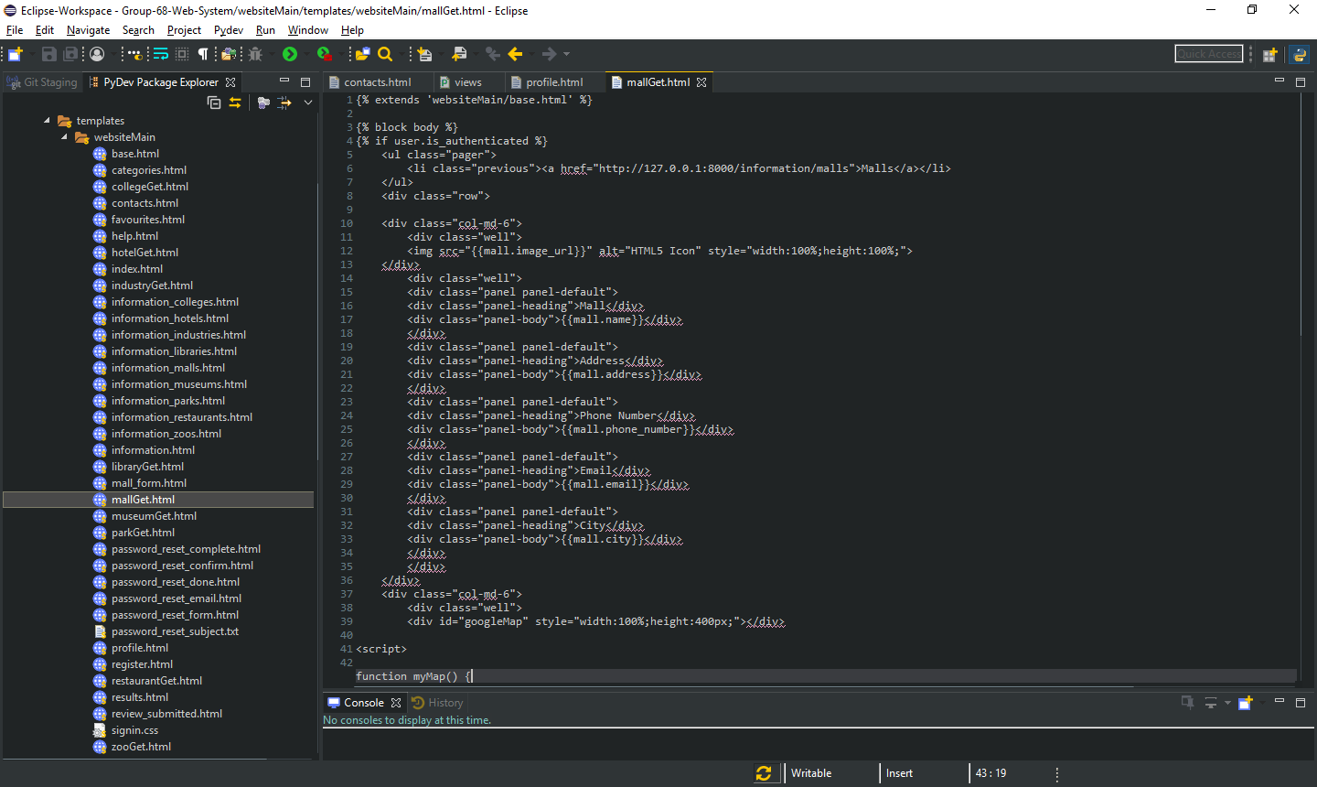

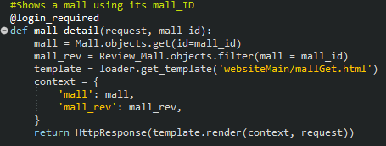

Description: This page shows specific information from the database pertaining to Place of Interest. I designed Individual HTML pages for each category and implemented python code to show this data from the database.

Github: <https://github.com/NickIsReady/Group-68-Web-System/blob/master/websiteMain/templates/websiteMain/mallGet.html>

Relevant story from sprint – 12

**Artefact 4** – (Associated Test Cases)



Description: These are the test cases conducted for the previously mentioned artifacts.   
(N/R/U)

Github: <https://github.com/NickIsReady/Group-68-Web-System/blob/master/Test%20cases.docx>

Relevant story from sprint – 12, 18, 21